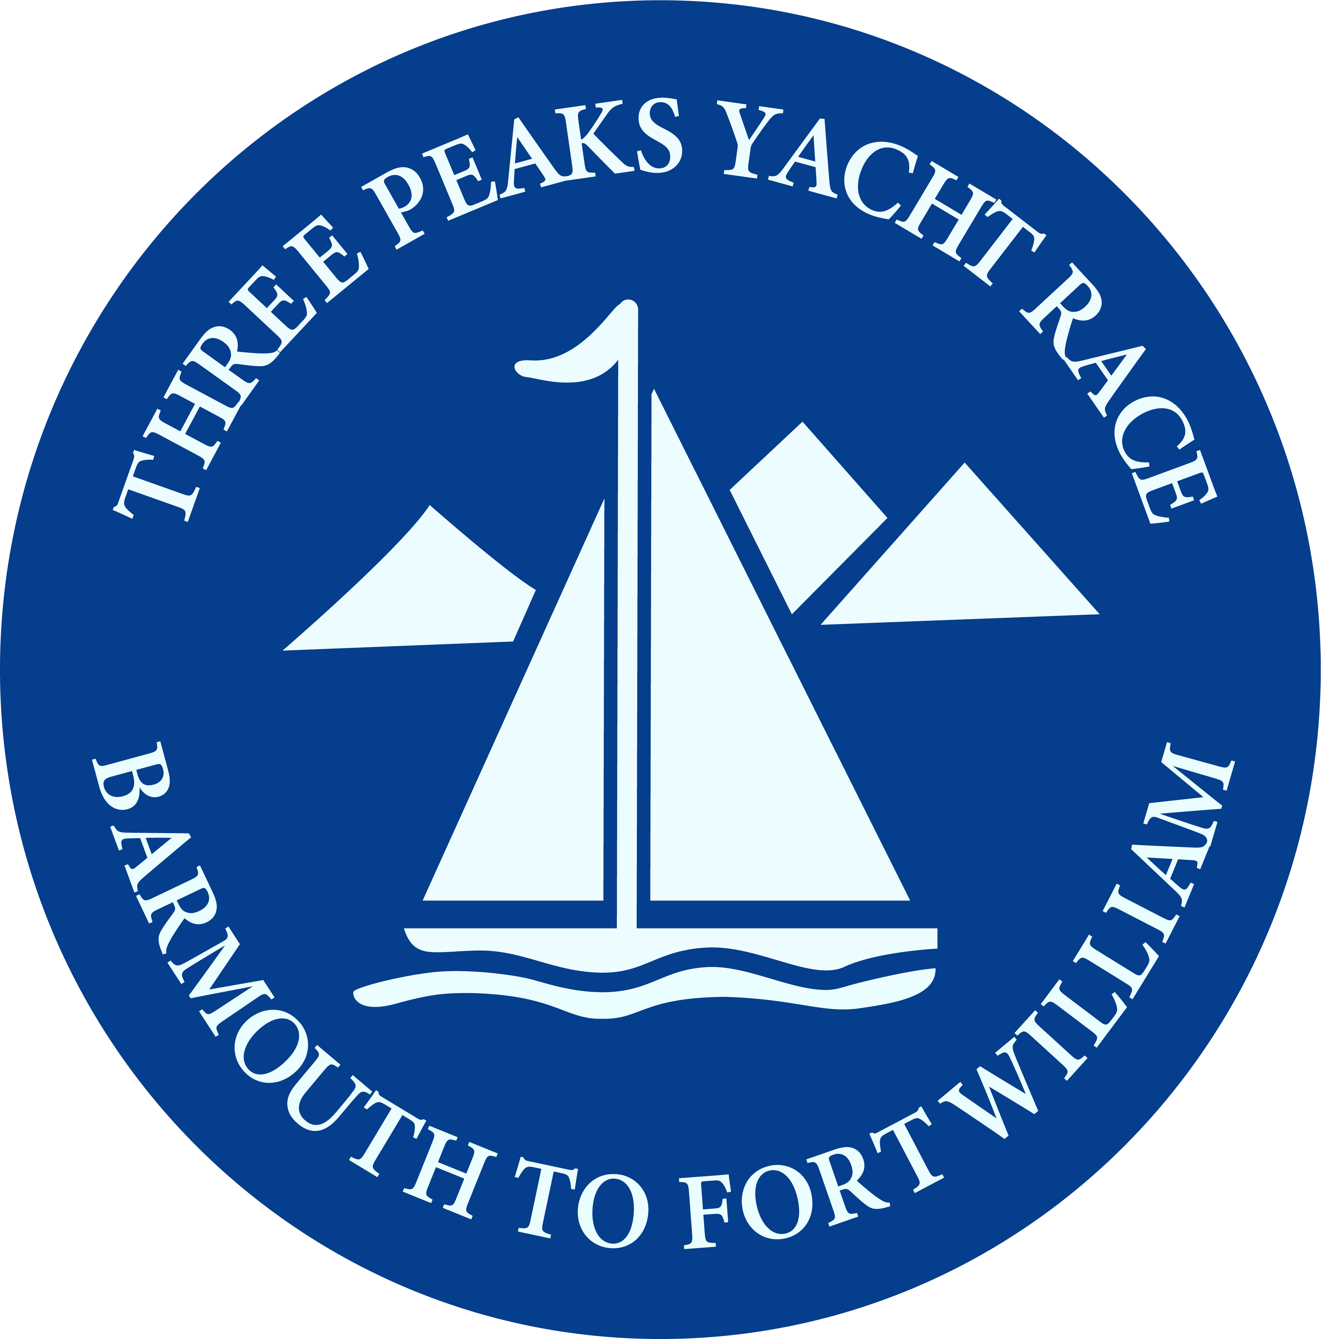
BARMOUTH TO FORT WILLIAM
THREE PEAKS YACHT RACE

ENTRY FORM 2023

I wish to enter The Three Peaks Yacht Race / Challenge starting 10th June 2023.

I agree to abide by the rules of the Race including instructions as laid down by the organising committee. I agree that the decision of the Protest Panel appointed by the committee shall be final with respect to all matters concerning the Race.

I further agree that I accept all risks associated with participating in the Race, also that the Committee and/or all members of the Race organization shall have no liability whatsoever in respect of any loss or damage of any kind, howsoever caused, arising from my participation in the Race.

I also agree that only persons who accept the aforementioned risks shall be members of the crew of the yacht entered and that I shall only accept them as crew members after they have signed the appropriate form to this effect.

I am aware some members of the crew will climb the highest mountains in Wales, England, and Scotland.

I affirm that the details given in the entry form are correct, and that if they change I will at once inform the Race Secretary. I also affirm that the yacht will be covered by at least third party insurance from the time of arrival at Barmouth until the yacht completes or retires from the Race.

Signed: …………………………………….. Date: …………

NAME AND ADDRESS: (In Block Capitals)

……………………………………………………………………………………………………………………….

………………………………………………………………………………………………………………………

……………………………………………………………… POST CODE ………………………..

Phone No: ……………………………

E.MAIL ADDRESS: …………………………………………………

Team Name: …………………………………………………………………………..

Race or Challenge? ………………………………………………………………….
PAYMENT

The entry fee for the 2023 race or challenge is £1250 per team.

Please email the completed entry form to

secretary@threepeaksyachtrace.co.uk

BACS Payments can be made to the Three Peaks Yacht Race bank account :-
Sort Code - 52 30 32 - Account - 14025442

Or a cheque to Three Peaks Yacht Race

Secretary Three Peaks Yacht Race
c/o Merioneth Yacht Club
The Quay
Barmouth
Merioneth
LL42 1HB

Thank you

